APPLICATION ARCHITECTURE
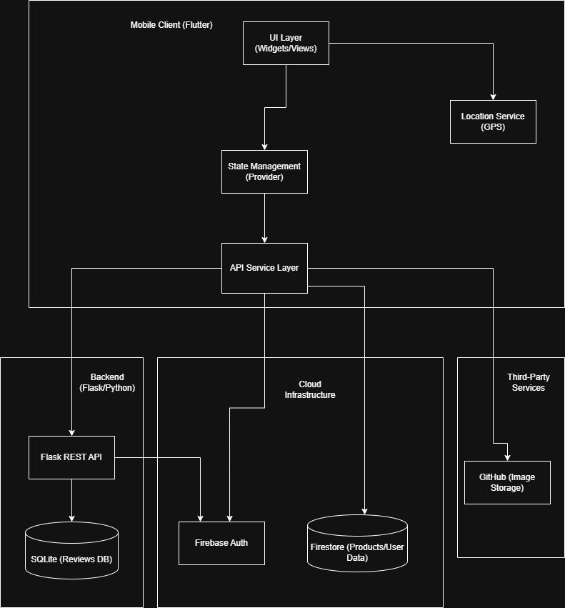

Description
- Flutter Mobile Application (Frontend)
  - UI Layer: modular widgets and screens following Material Design;
  - Provider: manage data like shopping cart and user favourites;
  - Centralized services like RevieService and GitStorageService, handle HTTP requests and data mapping;
  - Location Services: Uses device GPS to calculate proximity between users and shops for real-time product filtering.
- Flask REST API (Backend)
  - Endpoints: provides CRUD operations for product reviews;
  - Security: Verifies Firebase ID Tokens (JWT) sent from the mobile app to ensure only authenticated users can post/edit reviews;
  - Storage: Uses at-file SQLite for lightweight, persistent storage of review metadata.
- Cloud Infrastructure
  - Firebase Authentication: Manages secure user login (Email/Password, Google);
  - Google Firestore: A NoSQL database storing the primary product catalog, shop details, and user profiles.
- Third Party Services
  - GitHub API: Leverages GitHub as a Content Delivery Network (CDN) for product images, managed via the GitStorageService.

NAVIGATION GRAPH
